Pro Forma Sheet
Walters Hospitality
Part 1: Pre-LOI

1. Frame the venue
Market  Current market  New market | Performing or growth?  Already doing well  Growth opportunity | Vendor services  What they do today vs. what we implement, and how fast  Our marketing to fill events | Employee structure  Overstaffed or understaffed?  Owner involved or hands-off?

2. Key terms
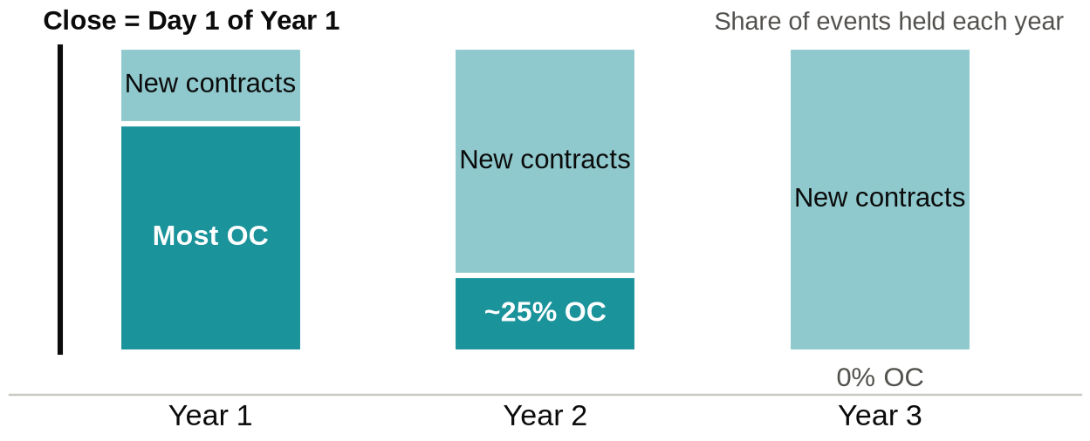
Year 1 / 2 / 3 | Pro forma years. Year 1 starts the day we close.
OC events | Original Contract events; booked before close. Mostly Year 1, some Year 2, rarely Year 3. We want a healthy number; a year only holds so many.
New contracts | Events we assume will book after close; they can land in Year 1, 2 or 3.

3. Market
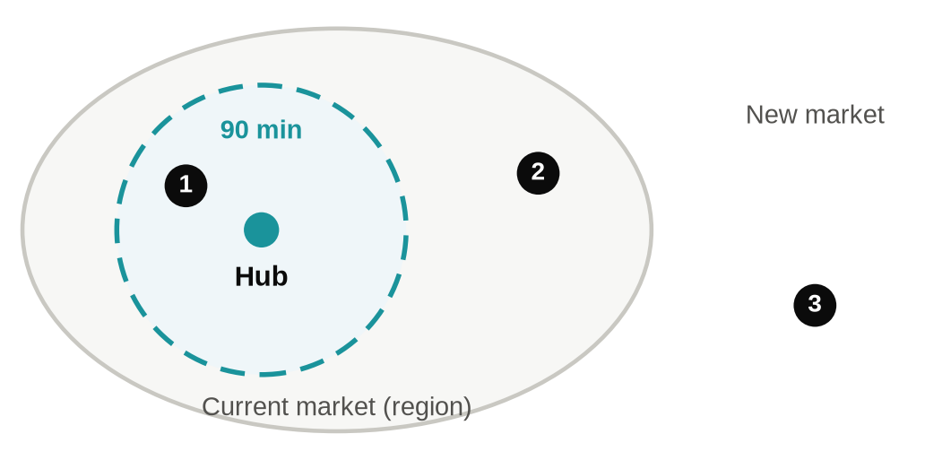
1 Current market, in hub range | Within 90 minutes of our hubs.  Vendor services modeled in Years 1 to 3 on our ramp.
2 Current market, outside hub range | In the broader region; likely grouped operationally with it.  Too far to use our hubs, so hub services start at $0.  Question: do we grow that direction and open hubs that can service it?
3 New market | Venue must stand on its own.  Vendor services may be a couple of years out, once volume exists.

The perfect new-market venue
~100 events / year  Real volume from day one | All-inclusive package  Partnering with outside vendors, or some in-house | Owner not involved  Runs without them

4. Top-Line Projections
Events
- Historical average per year
- Last 12 months
- Booked for the next 12 months
Revenue / Vendor Services
- Photography / DJ / Stationery: quick to implement
- Bar: on/off switch once we hold the liquor license
- Catering: attach slowly; test it
- Floral / Bakery: depends on hub distance
Attachment ramp-up
Our typical assumption: ramp to the Walters average attachment by Year 3, tweaked for the venue.
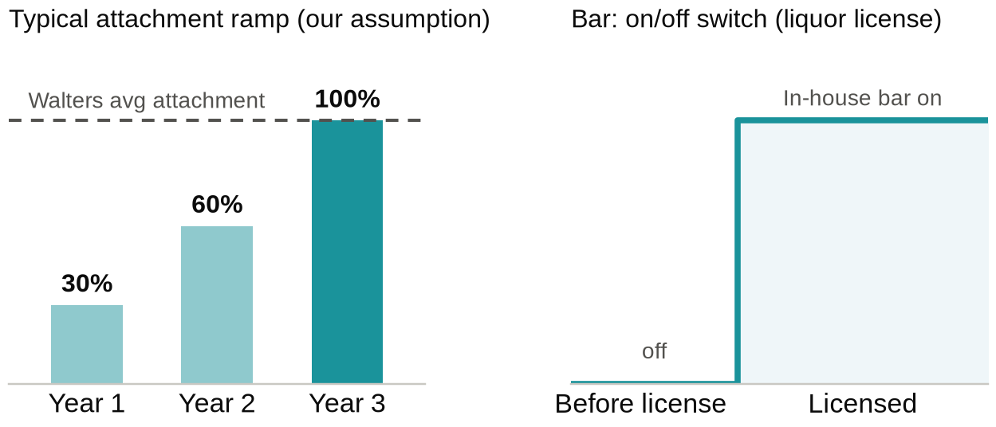
$ per vendor service
- Walters average $ per event for that service
- Small venue: tweak down; almost never tweak up
- Sanity-check against what brides at that venue actually spend
Don't "Walterize" too fast
- Test and attach slowly; catering is not 100% on day one

5. Expenses
COGS  - Depends on their vendor services and other offerings  - Keep theirs in mind (e.g. a required caterer's per-head cost on OC events)  - Often they have little or no COGS; we implement on our ramp and margins | Payroll  - Who they employ today  - Current or new market  - How involved the owners are; what they pay themselves; replacement cost | Operating expenses  - Switch to our marketing; almost always higher  - Their utilities and maintenance per event  - Our insurance, finance expenses, professional services

